MATERIAL SAFETY DATA SHEET

. Identification of the substance/preparation and of the company/undertaking

Product Name: EuroBlue
Recommend Use: To reduce diesel engine emissions
in SCR exhaust systems
Supplier: Euroblue Pty Ltd 3 Whittle Rd
Rockingham, WA 6168
Telephone: 1800 335 730
Emergency telephone
Poisons Information Centre – 13 11 26 or
www.poisonsinfo@nsw.gov.au Date of Issue: 01/05/2025

Facsimile: Email:
1800 288 903
info@adblueaustralia.com

Composition/information on ingredients

Chemical description: Chemical Entity Carbamide
Non hazardous
Water
EuroBlue AUS32 Solution
CAS-number 57-13-6
(7732-18-5)

Proportion 32.5.00%
<2.00%
to 100%

Hazards identification
Prolonged exposure at high concentration may lead to drying of the skin. Non-Hazardous according to criteria of work safe Australia.

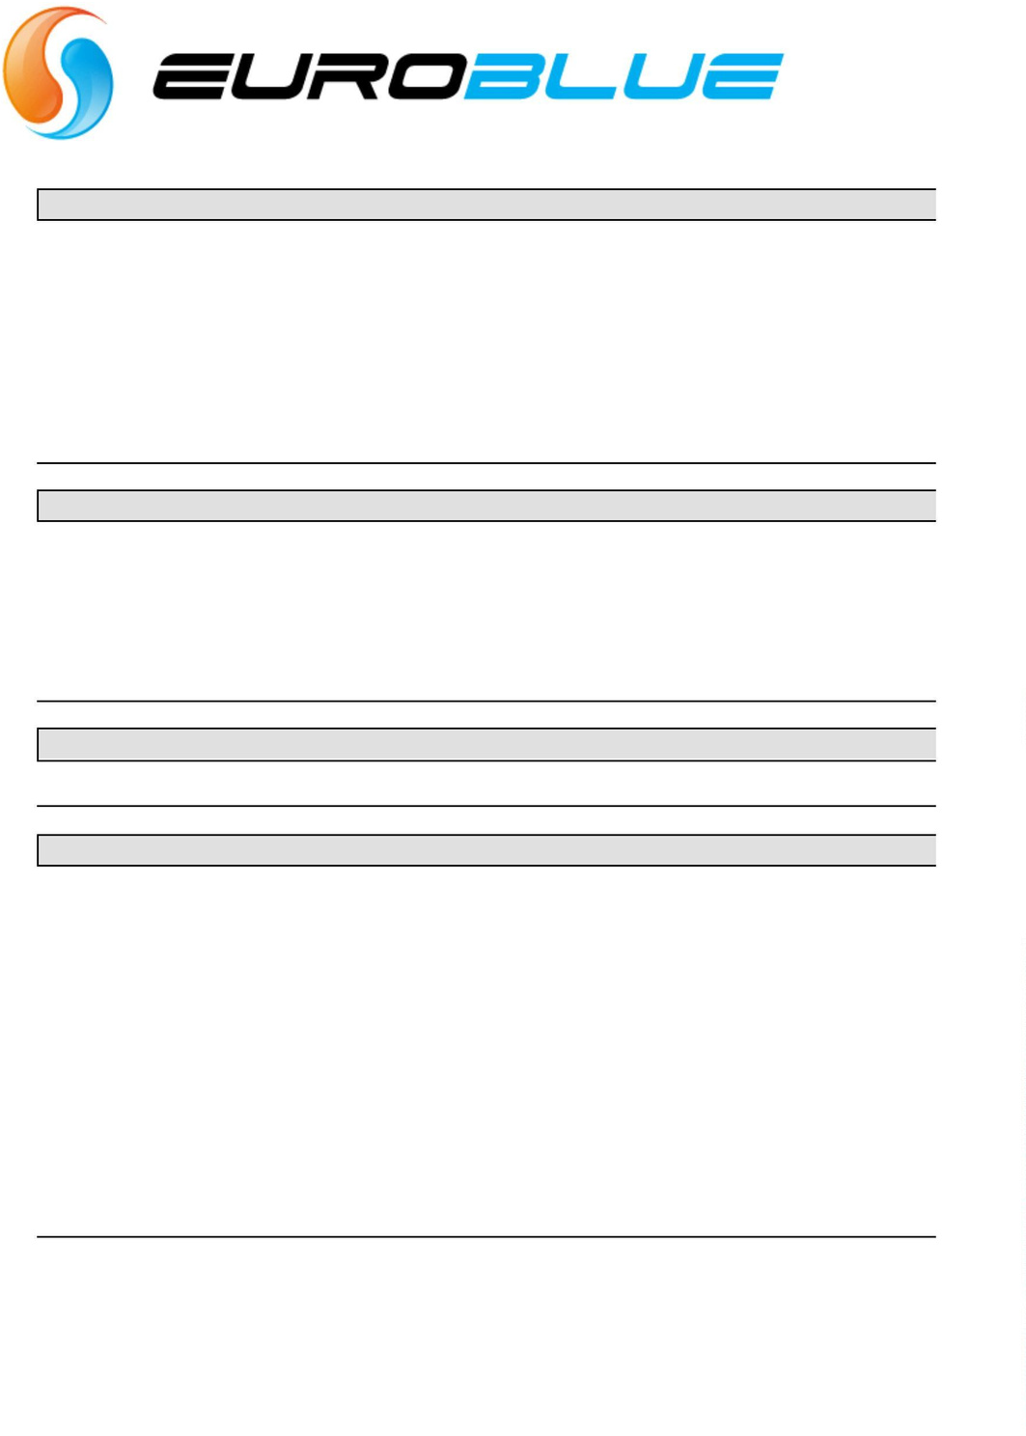
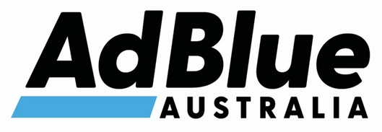
First-aid measures
Symptoms and effects
First-aid Ingestion Inhalation

Skin

Eye

Advice to physician

Can cause irritation and discomfort to mouth, throat and Gastro intestinal tract
Wash mouth with water, DO NOT induce
vomiting and seek medical advice immediately Remove victim to fresh air away from contaminated area. Loosen clothing and allow patient to be comfortable. Seek medical advice if effects persist.
Remove contaminated clothing and wash affected areas with copious amounts of running water. Seek medical attention if skin appears to be damaged
Immediately wash eyes with copious amounts of water for at least 15 minutes, holding eyelids open. Seek medical attention
Treat Symptomatically

MATERIAL SAFETY DATA SHEET

Fire-fighting measures
Extinguishing
Unsuitable extinguishing media Special exposure hazards Hazardous decomposition/ combustion products
Protective equipment

All media none
If involved in a fire, it is non-combustible. However, it will breakdown under fire condition and organic material will burn.

Accidental release measures

Personal precautions Environmental precautions Methods for cleaning up

For personal protection see Section 8. Do not empty into drains.
Absorb spill with sand or similar material and Collect in a sealable container for disposal. The ground will be slippery when spilt

Handling and storage
Handling
Fire and explosion prevention Storage requirement

The usual precautions for handling chemicals should be observed.
This material is not combustible under normal conditions
Store in a cool place away from sunlight, keep container sealed when not in use

Exposure controls/personal protection
Engineering controls Exposure limits Personal protection
Respiratory
Hand Eye
Skin and body

Use only in a well ventilated area. If mists are generated use local exhaust ventilations
Ventilation
Mask can be used PVC or rubber gloves safety goggles protective clothing

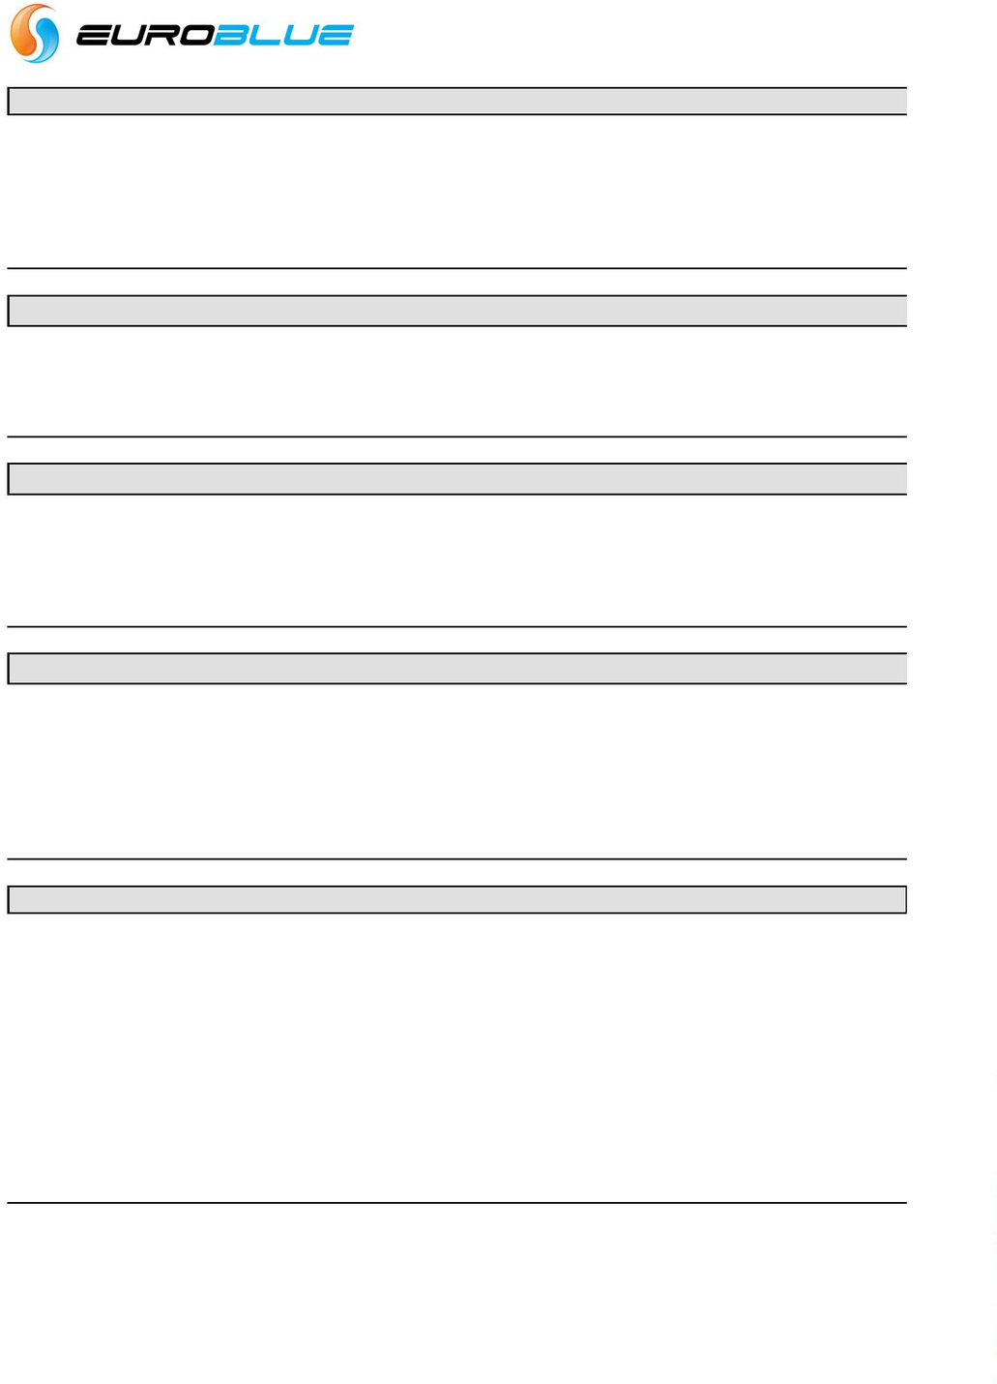
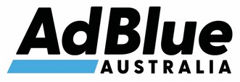
Physical and chemical properties
Appearance Colour Odour
Boiling point/range Flammability Vapour pressure Solubility in water
Solubility in other solvents pH value
Specific Gravity
Relative vapour density (air=1) Freezing point
liquid Clear Mild 100°C
not flammable N/A
Soluble
Nil 9.80
1.09 Kg/L
6.5Kpa
-14.6°C

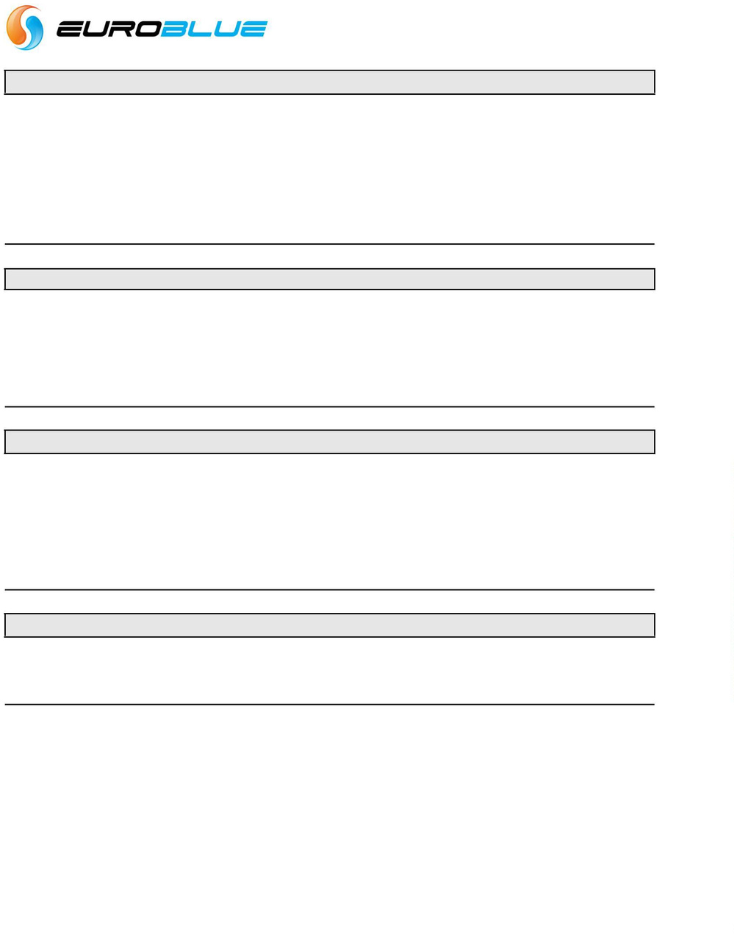

MATERIAL SAFETY DATA SHEET

10Stability and reactivity
Stability Conditions to avoid

Materials to avoid Hazardous decomposition products

Stable
Reaction with strong acids, oxidizing agents and alkalis.
Deactivated by other detergents
Protect against heat and direct sunlight. Reacts with calcium and sodium hypochlorite Co,co2, nitrogen oxides and ammonia

11Toxicological information
Name
Acute toxicity Oral LD50 Dermal LD50 Inhalation LD50 Irritation

EuroBlue AUS32 Solution
= No data mg/kg (rat) = not available = not available

12Ecological information
No experimental ecological data are available on the preparation as such.

Name Ecotoxicity fish daphnia algae
Fate
Degradation Abiotic
EuroBlue AUS32 Solution
Acute toxicity, 96h-LC50: 6-32 mg/l

13Disposal considerations
Product
Contaminated packaging
Waste disposal in accordance with regulations.
Waste disposal in accordance with regulations.


MATERIAL SAFETY DATA SHEET

14Transport information Land transport (ADR/RID) ADR class
RID class
Hazard Identification No. TREM-Card
Proper Shipping Name Other information Sea transport (IMDG-code/IMO) IMO/IMDG code Packing group
EMS
Marine pollutant Proper Shipping Name Other information
Air transport
(ICAO-TI/IATA-DGR)
ICAO-TI/IATA-DGR
Class
Proper Shipping Name

15Regulatory information
Chemical description
Labeling according to EC directives EC-number
Classification based on Symbol(s)
R(isk) phrase(s) S(afety) phrase(s)

8 ADR Classification N/A
8 ADR/RID packing group N/A 80 Substance Identification No
CEFIC TEC(R)-80GC9-II+II UN Number N/A
EuroBlue AUS32 Solution Transport label(s): Not hazardous

Class N/A
UN number N/A
F-A, S-B Subsidiary Risk no
EuroBlue AUS32 Solution Transport label(s):None Hazardous

UN number N/A
None Hazardous Packing group Nil EuroBlue AUS32 Solution

EuroBlue AUS32 Solution See section 2
Annex-1 Corrosive (C)
R36/37/38: Irritating to the eyes, respiratory system and skin
S02: Keep out of the reach of children S28/26: After contact with skin and the eyes wash immediately with plenty of soap and water, seek medical attention
S44: In case of accident or id you feel unwell, seek medical advice immediately (show the label where possible)
S50: Do not mix with other detergents

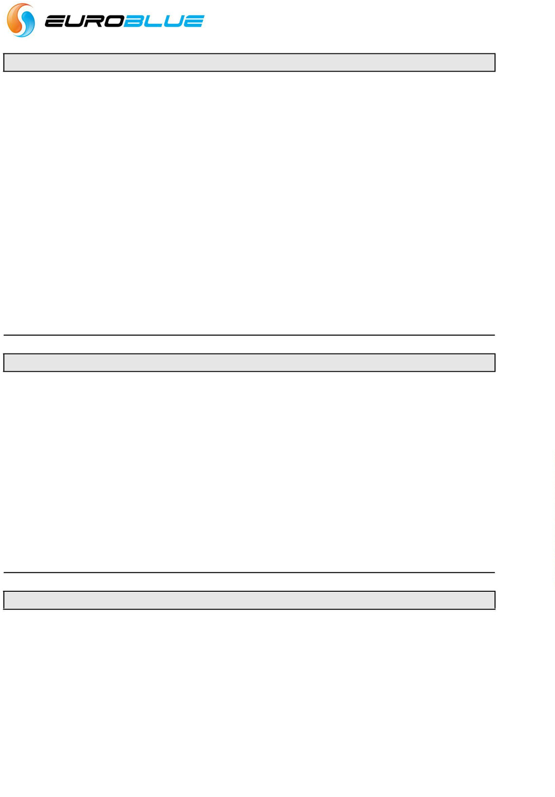

16Other information
This information only concerns the above mentioned product and does not need to be valid if used with other product(s) or in any process. The information is to our best present knowledge correct and complete and is given in good faith but without warranty. It remains the user’s own responsibility to make sure that the information is appropriate and complete for his special use of this product.

